Project Initialization and Planning Phase

Date | 28 January 2026
Team ID | LTVIP2026TMIDS49772
Project Name | TransLingua: AI-Powered Multi-Language Translator
Maximum Marks | 3 Marks

Define Problem Statements:
In today’s global digital ecosystem, individuals frequently need to communicate across language barriers, whether for education, business, research, or social interaction. However, many existing translation tools lack contextual understanding, often generating literal translations that may be inaccurate or awkward. Additionally, some platforms have complex interfaces that reduce usability and make the translation process less efficient. Therefore, users require a fast, accurate, and AI-powered translation solution that supports multiple global languages, understands contextual meaning rather than word-by-word translation, provides an intuitive and accessible user interface, and ensures secure handling of user input.
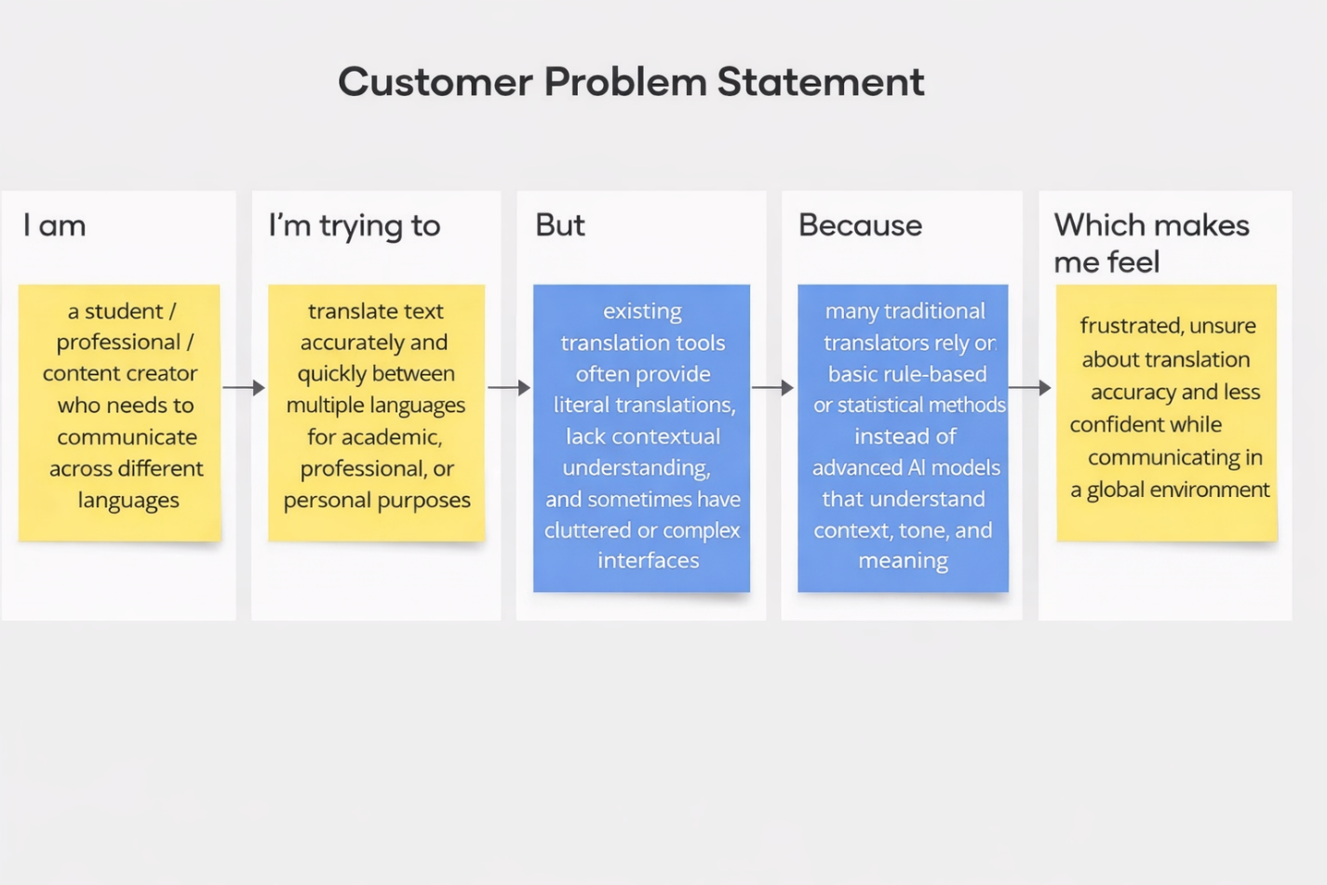

Problem  Statement  (PS) | I am | I’m trying to | But | Because | Which makes me feel
PS-1 | A student who needs to translate academic content and research materials. | Translate text accurately and quickly between multiple languages for assignments and international collaboration. | Existing translation tools often provide literal translations and fail to capture contextual meaning. | Many platforms rely on basic rule-based or statistical methods instead of advanced AI models that understand context and tone. | Frustrated, uncertain about accuracy, and less confident while submitting academic work.
PS-2 | A working professional communicating with international clients. | Translate business emails and documents clearly and professionally. | Available online translators sometimes generate awkward or grammatically incorrect sentences. | They lack advanced AI-driven contextual understanding and domain awareness. | Unsure about communication quality and worried about professional credibility

